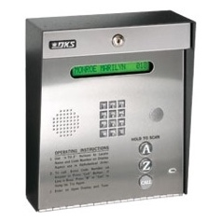
Surfside II COA: Entry Gate System Directory

Purpose: To add, remove correct the gate entry telephone number for your unit in order to open the electric gate for your visitors (and to give yourself access if you are using your cell number.)
Result: You will be able to open the driveway gate when a guest inputs your unit code by scrolling for Name and pressing Call button. The system will call your designated telephone (land or cell) and when you confirm it is indeed someone you know, press 9 and the gate will open.
Important:
- Past residents will not maintain an entry code for access to the SSII parking lot. Unknown names will be deleted.
- Owners with renters will advise our management company when their tenancy changes
- The entry gate number caller ID is an 805 area code. It is dialing your designated phone. Please change its caller ID to “Entry Gate SSII.”
- If you are NOT expecting guests or service people, do not press “9” unless you identify & know the caller.
Surfside II COA
----------------------------------------------------------------------------------------------------------------------------------------
Gate Entry Phone Number Form www.Surfsideiicoa.com Please print clearly

SURNAME to show on display ____________________________________________Unit #_________
Telephone number for gate:

1 ____ ____ ____ ----- ___ ___ ___ ___ ___ ___ ___
Area Code

This number is the (check one) Owner Tenant
Check any that apply.
This is a new entry to the gate system.
I am changing my entry code telephone number.
Please DELETE the following from the gate system (i.e. previous owner or resident):
Surname____________________________________ Unit # __________

Your contact telephone if we have questions: ____________ ____________________________

Your email address ________________________________________________________________

Return or email form to:
SS II COA
c/o The Management Trust 100 E Thousand Oaks Blvd., Ste. 115 Thousand Oaks, CA 91360

See Management contacts on website: www.surfsideiicoa.com

